Day 1 - Task

1. Write a blog on Difference between HTTP1.1 vs HTTP2

HTTP- Hyper Text Transfer Protocol (HTTP) is an application-layer protocol for transmitting hypermedia documents, such as HTML. It was designed for communication between web browsers and web servers.



Difference between HTTP1.1 vs HTTP2

HTTP2 is much faster and more reliable than HTTP1. HTTP1 loads a single request for every TCP connection, while HTTP2 avoids network delay by using multiplexing.

HTTP is a network delay sensitive protocol in the sense that if there is less network delay, then the page loads faster. However, an impressive increase in network bandwidth only slightly improves page load time

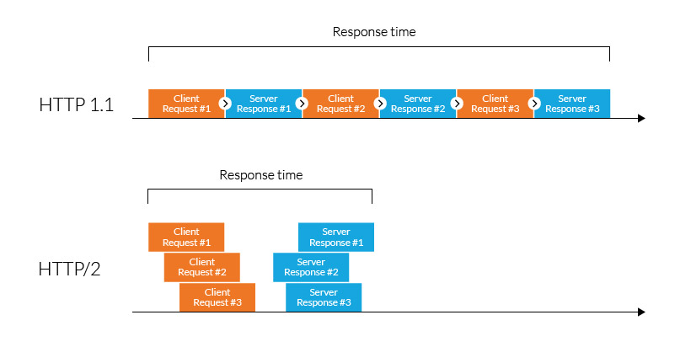

1. Write a blog about objects and its internal representation in Javascript

Object

In JavaScript, almost "everything" is an object.

* Booleans can be objects (if defined with the new keyword)
* Numbers can be objects (if defined with the new keyword)
* Strings can be objects (if defined with the new keyword)
* Dates are always objects
* Maths are always objects
* Regular expressions are always objects
* Arrays are always objects
* Functions are always objects
* Objects are always objects

All JavaScript values, except primitives, are objects.

Objects are important data types in javascript. Objects are different than primitive datatypes (i.e. number, string, boolean, etc.). Primitive data types contain one value but Objects can hold many values in form of Key: value pair. These keys can be variables or functions and are called properties and methods, respectively, in the context of an object.

Every object has some property associated with some value. These values can be accessed using these properties associated with them.

var myCar = new Object();

myCar.make = 'Suzuki';

myCar.model = 'Altros';

myCar.year = 1978;

myCar.wheels = 4;

After creating myCar object, the value inside the object can be accessed using keys.

i.e.

myCar.year

Output: 1978